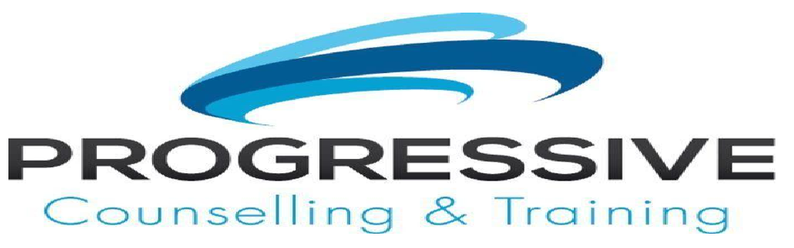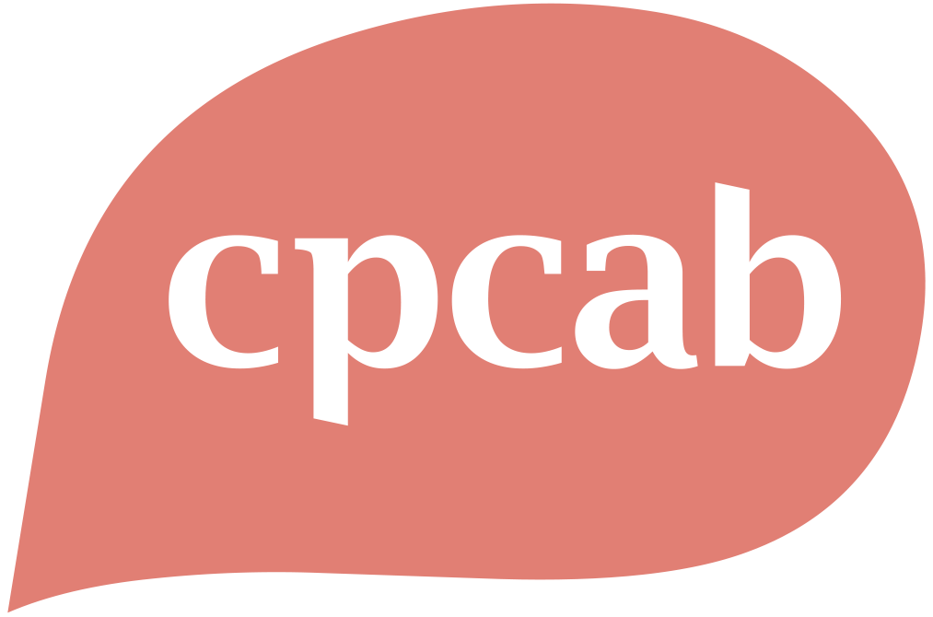
Level 6 Clinical Supervision Training Course
ENROLMENT FORM • NOVEMBER 2026 INTAKE
Course commencement: 8 November 2026 | Fully online
Thank you for enquiring about the Level 6 Clinical Supervision Training Course. To confirm your place, please complete this form, pay the £250 deposit and return the completed form to Phill Smith at phil@progressivecounselling.org.
1. Candidate Details
Full name
Date of birth
Address
Telephone number
Email address

Entry Requirements
2. Entry Requirements
Please confirm how you meet the course entry requirements and provide relevant qualification and post-qualifying experience details.
☐ I have reviewed the official CPCAB qualification requirements.
☐ I confirm that I meet the entry requirements for this qualification.
Relevant qualification(s)
Year qualified
Post-qualifying supervised client work
Current counselling role and supervision arrangements
Access to supervisees
Supervision arrangements for supervision practice

Fees and Payment Agreement
3. Course Fees
To reserve your place, a deposit of £250 is payable at the time of booking. Following payment of the deposit, six monthly payments of £185 will be due on the 15th of each month from November to April inclusive.
A separate CPCAB registration fee of £398 is also payable. Payment will be requested in December, once the group has been registered with the awarding body.
Payment item | Amount | Candidate initials
Deposit payable when booking | £250
Six monthly payments | £185 each
CPCAB registration fee payable in December | £398
Total programme cost | £1,758

4. Payment Details
Account name | Phillip Smith
Account number | 45161527
Sort code | 60-83-71
Please use your full name as the payment reference.

5. Fee Commitment and Withdrawal
By accepting a place on the programme, you agree to pay the full course fees. If you withdraw after the course has commenced, any outstanding course fees will remain payable in full.

Candidate Declaration and Course Information
6. Candidate Declaration
☐ I confirm that the information provided in this enrolment form is accurate.
☐ I confirm that I meet the qualification entry requirements.
☐ I have reviewed the CPCAB course information and understand the course requirements.
☐ I agree to the payment schedule and fee commitment set out above.
Candidate name
Signature
Date

Before You Enrol
Before enrolling, please review the official CPCAB qualification information to ensure that you understand the course purpose, entry requirements, practice requirements and progression opportunities.
https://www.cpcab.co.uk/qualifications/tcsu-l6

Submitting Your Enrolment Form
Please return your completed enrolment form to:
Phill Smith
phil@progressivecounselling.org
07906 663730

Checklist Before Submission
☐ All personal details have been completed
☐ Entry requirement information has been provided
☐ The candidate declaration has been signed and dated
☐ The £250 deposit has been paid using your full name as the reference
Your place cannot be confirmed until the completed enrolment form and deposit have been received.

