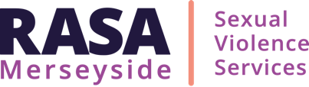

RASA SAFEGUARDING CHILDREN POLICY AND PROCEDURE

VERSION CONTROL
REVIEWED/ UPDATED | NEXT REVIEW DATE | APPROVED BY
April 2026 | April 2027 | Janet Bunn

RASA Merseyside Safeguarding Statement

RASA is committed to safeguarding and promoting the welfare of children and expects all staff and volunteers to share this commitment.

We have policies and procedures in place that contribute to our safeguarding commitment, including our Safeguarding Adults Policy and Procedure, and Safeguarding Children Policy and Procedure.

Sometimes we may need to share information and work in partnership with other agencies when there are concerns about a child's welfare. We will ensure that our concerns about our child clients are discussed with his/her parents/carers first unless we have reason to believe that such a move would be contrary to the child's welfare.
Safeguarding Children Policy and Procedure
Introduction
RASA are committed to providing confidential services to women, men, young people and children who have or are experiencing sexual violence. RASA Merseyside aims to ensure that staff and/volunteers who have contact with vulnerable persons (children and/or adults) and, who in the course of their work, may become aware of situations where there is a risk of, or actual abuse, are able to act competently and confidently to protect that individual from further abuse or harm.
This policy is underpinned by the policies and procedures devised by Sefton/ Liverpool/ Wirral Local Safeguarding Partnerships and is underpinned by Working Together to Safeguard Children 2023 and Working Together to Safeguard Children 2026 update. It is child-centred, trauma-informed, and focused on understanding the child’s lived experience.
We work proactively within multi-agency safeguarding arrangements, sharing information appropriately and without delay where there are concerns about a child’s safety.
We recognise that harm may occur both within and outside the family environment and respond using a contextual safeguarding approach. Staff maintain professional curiosity, challenge where necessary, and escalate concerns to ensure effective safeguarding responses.
1. Purpose
This policy aims to ensure that no act or omission by staff or the services they provide puts a service-user at risk; and that systems are in place to proactively safeguard and promote the welfare of children and to protect them from abuse. The policy recognises that safeguarding children is a shared responsibility with the need for effective joint working between agencies and professionals that have different roles and expertise if children are to be protected from harm.
This policy also sets out how staff should be alert to signs of abuse and takes appropriate action to safeguard children.

2. Definition
2.1 A child is defined as anyone who has not yet reached their 18th birthday (Children Act 1989 and 2004). The fact that a child has reached 16 years of age is living independently or is in further education, is a member of the armed forces, is in hospital, prison or a young offender’s institution does not change his or her status or entitlement to services or protection under the Children Act 1989 and 2004. Young people who are in this category as well as younger adolescents often fall through the net of services, not seen as an adult but no longer a child; they are often very vulnerable. Whilst ‘unborn children’ are not included in the legal definition of children, intervention to ensure their future well-being is encompassed within safeguarding children practice Working Together to Safeguard Children (2023).
3. Abuse of Children:
For children’s safeguarding, the definitions of abuse are taken from Working Together to Safeguard Children (2023)
Abuse - A form of maltreatment of a child. Somebody may abuse or neglect a child by
inflicting harm, or by failing to act to prevent harm. Harm can include ill treatment that is
not physical as well as the impact of witnessing ill treatment of others. This can be
particularly relevant, for example, in relation to the impact on children of all forms of
domestic abuse, including where they see, hear, or experience its effects. Children may
be abused in a family or in an institutional or extra-familial contexts by those known to
them or, more rarely, by others. Abuse can take place wholly online, or technology may
be used to facilitate offline abuse. Children may be abused by an adult or adults, or
another child or children.

Child criminal exploitation - As set out in the Serious Violence Strategy230, published by
the Home Office, where an individual or group takes advantage of an imbalance of power
to coerce, control, manipulate or deceive a child or young person under the age of 18 into
any criminal activity (a) in exchange for something the victim needs or wants, and/or (b)
for the financial or other advantage of the perpetrator or facilitator and/or (c) through
violence or the threat of violence. The victim may have been criminally exploited even if
the activity appears consensual. Child criminal exploitation does not always involve
physical contact; it can also occur through the use of technology.
Child sexual exploitation - Child sexual exploitation is a form of child sexual abuse. It
occurs where an individual or group takes advantage of an imbalance of power to coerce,
manipulate or deceive a child or young person under the age of 18 into sexual activity (a)
in exchange for something the victim needs or wants, and/or (b) for the financial
advantage or increased status of the perpetrator or facilitator. The victim may have been
sexually exploited even if the sexual activity appears consensual. Child sexual exploitation
does not always involve physical contact; it can also occur through the use of technology.
Controlling or coercive behaviour - Also known as coercive control, controlling or
coercive behaviour is a form of domestic abuse. In 2015, the offence of controlling or
coercive behaviour was introduced under Section 76 of the Serious Crime Act as a
criminal offence. Controlling or coercive behaviour is included in the definition of domestic
abuse in section 1(3)(c) of the Domestic Abuse Act 2021.
Controlling or coercive behaviour is a pattern of abuse (on two or more occasions) that
involves multiple behaviours and tactics used by a perpetrator to (but not limited to) hurt,
humiliate, intimidate, exploit, isolate, and dominate the victim. It is an intentional pattern of
behaviour used to exert power, control, or coercion over another person. Controlling or
coercive behaviour is often committed in conjunction with other forms of abuse and is
often part of a wider pattern of abuse, including violent, sexual, or economic abuse.
Children can be used to control or coerce the victim, for example, by frustrating child
contact and/or child arrangements, telling the children to call the victim derogatory names
or to hit the victim, or by threatening to abduct the children.
This pattern of abuse causes fear, serious alarm and/or distress which can lead to a
substantial adverse effect on a victim’s day-to-day life. This can have a significant impact
on children and young people231
.
Section 68 of the Domestic Abuse Act 2021 came into force on 5 April 2023 and removed
the ‘living together’ requirement for the controlling or coercive behaviour offence, which
means that the offence applies to partners, ex-partners or family members, regardless of
whether the victim and perpetrator live together. More information about controlling or
coercive behaviour, including the impact on children can be found in the Controlling or
coercive behaviour: statutory guidance232 and the Domestic Abuse Act 2021: statutory
guidance233.

County lines - As set out in the Serious Violence Strategy234 published by the Home
Office, a term used to describe gangs and organised criminal networks involved in
exporting illegal drugs into one or more importing areas within the UK, using
dedicated mobile phone lines or other form of ‘deal line’. They are likely to exploit
children and vulnerable adults to move and store the drugs and money, and they will
often use coercion, intimidation, violence (including sexual violence) and weapons.
This activity can happen locally as well as across the UK; no specified distance of travel is
required. For further information see ‘Criminal exploitation of children and vulnerable
adults: county lines’ guidance235
.
Domestic abuse - The Domestic Abuse Act 2021 236 introduced the first ever statutory
definition of domestic abuse (section 1 of the Act). The statutory definition is clear that
domestic abuse may be a single incident or a course of conduct which can encompass a
wide range of abusive behaviours, including a) physical or sexual abuse; b) violent or
threatening behaviour; c) controlling or coercive behaviour; d) economic abuse; and e)
psychological, emotional, or other abuse.
Under the statutory definition, both the person who is carrying out the behaviour and the
person to whom the behaviour is directed towards must be aged 16 or over and they must
be “personally connected” (as defined in section 2 of the Domestic Abuse Act 2021). The
definition ensures that different types of relationships are captured, including ex-partners
and family members.

All children can experience and be adversely affected by domestic abuse in the context of
their home life where domestic abuse occurs between family members, including where
those being abusive do not live with the child. Experiencing domestic abuse can have a
significant impact on children. Section 3 of the Domestic Abuse Act 2021 recognises the
impact of domestic abuse on children (0 to 18), as victims in their own right, if they see,
hear or experience the effects of abuse.

Young people can also experience domestic abuse within their own intimate relationships.
This form of child-on-child abuse is sometimes referred to as teenage relationship abuse.
Depending on the age of the young people, this may not be recognised in law under the
statutory definition of domestic abuse (if one or both parties are under 16). However, as
with any child under 18, where there are concerns about safety or welfare, child
safeguarding procedures should be followed and both young victims and young
perpetrators should be offered support.
The ‘Domestic Abuse Act 2021: statutory guidance’237 provides further advice for frontline
professionals who have responsibility for safeguarding and supporting victims of domestic
abuse, including children. This guidance provides further information about the different
forms of domestic abuse (including teenage relationship abuse and child to parent abuse)
and the impact of domestic abuse on children.
Emotional abuse - The persistent emotional maltreatment of a child so as to cause
severe and persistent adverse effects on the child’s emotional development. It may
involve conveying to a child that they are worthless or unloved, inadequate, or valued only
insofar as they meet the needs of another person. It may include not giving the child
opportunities to express their views, deliberately silencing them, or making fun of what
they say or how they communicate. It may feature age or developmentally inappropriate
expectations being imposed on children. These may include interactions that are beyond
a child’s developmental capability, as well as overprotection and limitation of exploration
and learning, or preventing the child participating in normal social interaction. It may
involve seeing or hearing the ill-treatment of another. It may involve serious bullying
(including cyber bullying), causing children frequently to feel frightened or in danger, or
the exploitation or corruption of children. Some level of emotional abuse is involved in all
types of maltreatment of a child, though it may occur alone.
Harm Outside the Home - Children face various risks of abuse and exploitation beyond their families, as outlined in the glossary definition of extra-familial contexts. While lacking a precise legal definition, "extra-familial harm" broadly encompasses harm occurring outside the home. This harm can manifest in multiple forms and may involve criminal exploitation including by organised criminal gangs (OCGs), serious violence, modern slavery, financial abuse, trafficking, online harm, sexual exploitation (including exploitation by OCGs), child-on-child sexual abuse, all forms of abuse, coercive control, and the influences of extremism leading to radicalisation. Vulnerability to these forms of harm extends to children from both adults and peers. Such threats can emanate from diverse sources, including school, other educational establishments, recreational groups, sports groups, peer groups, the wider community, and online platforms. Examples encompass exploitation by criminal gangs, trafficking, online abuse, sexual exploitation, and exposure to extremist ideologies. Extremist groups leverage the internet for radicalisation, recruitment, and dissemination of extremist materials (Working Together to Safeguard Children, 2023).

Financial exploitation - Financial exploitation can take many forms. In this context, we
use the term to describe exploitation which takes place for the purpose of money
laundering. This is when criminals target children and adults and take advantage of an
imbalance of power to coerce, control, manipulate or deceive them into facilitating the
movement of illicit funds. This can include physical cash and/or payments through
financial products, such as bank and cryptocurrency accounts.
Neglect - The persistent failure to meet a child’s basic physical and/or psychological
needs, likely to result in the serious impairment of the child’s health or development.
Neglect may occur during pregnancy as a result of maternal substance abuse. Once a
child is born, neglect may involve a parent or carer failing to:

• provide adequate food, clothing, and shelter (including exclusion from home or
abandonment)
• protect a child from physical and emotional harm or danger
• ensure adequate supervision (including the use of inadequate caregivers)
• ensure access to appropriate medical care or treatment
• provide suitable education

It may also include neglect of, or unresponsiveness to, a child’s basic emotional needs.
Physical abuse - A form of abuse which may involve hitting, shaking, throwing,
poisoning, burning, or scalding, drowning, suffocating, or otherwise causing physical harm
to a child. Physical harm may also be caused when a parent or carer fabricates the
symptoms of, or deliberately induces, illness in a child.
Sexual abuse - Involves forcing or enticing a child or young person to take part in sexual
activities, not necessarily involving phyiscal violence, whether or not the child is
aware of what is happening. The activities may involve physical contact, including assault
by penetration (for example, rape or oral sex) or non-penetrative acts, such as
masturbation, kissing, rubbing, and touching outside of clothing. They may also include
non-contact activities, such as involving children in looking at, or in the production of,
sexual images, watching sexual activities, encouraging children to behave in sexually
inappropriate ways, or grooming a child in preparation for abuse. Sexual abuse can take
place online, and technology can be used to facilitate offline abuse. Sexual abuse is not
solely perpetrated by adult males. Women can also commit acts of sexual abuse, as can
other children.

On-Line Abuse Online abuse is any type of abuse that happens on the web, whether through social networks, chat rooms, playing online games, live streaming sites, using mobile phones, tablets, computes, laptops. Children and young people may experience cyberbullying, cyber stalking, cyber flashing, being sent sexual images, sexual extortion, being the subject of a deepfake child sexual abuse image, being the subject of a fake account, account hacking, grooming, sexual abuse, sexual exploitation, financial abuse or emotional abuse. The abuse may take place solely online or be a combination of online and offline.
Female Genital FGM is a criminal offence in the UK and the Female Genital Mutilation
Mutilation (FGM) Act 2003 makes it an offence for UK nationals or permanent UK residents to carry out FGM abroad, or to aid, abet, counsel or procure the carrying out of FGM abroad, even in countries where the practice is legal.

Radicalisation and Prevent
Prevent is part of the UK counter-terrorism strategy, CONTEST. Its aim is to stop people becoming terrorists or supporting terrorism. Prevent will address all forms of terrorism but continue to prioritise according to the threat they pose to our national security. At present, most resources and efforts will continue to be devoted to stopping people becoming terrorists or supporting terrorism. There is a commitment to protecting freedom of speech in the UK. But preventing terrorism will mean challenging extremist (and non-violent) ideas that are also part of a terrorist ideology. Prevent will also mean intervening to stop people moving from extremist groups or from extremism into terrorist-related activity.

Forced Marriage and Honour Based Violence

RASA understand forced marriage and honour-based violence to be a form of abuse and a breach of human rights. It is, therefore, important to safeguard any child, young person or adult subjected to a forced marriage or honour based violence. Forced marriage refers “a marriage conducted without the valid consent of one or both parties, where some element of duress is a factor” (Pan Merseyside Forced Marriage Protocol, 2019). The National Police Chiefs’ Council (NPCC) define honour-based abuse as:
‘an incident or crime involving violence, threats of violence, intimidation, coercion or abuse (including psychological, physical, financial or emotional abuse), which has or may have been committed to protect of defend the honour of an individual, family and / or community for alleged or perceived breaches of the family and / or community’s code of behaviour’ (NPCC 2015).

Modern Slavery Modern Slavery is the term used within the UK and is defined within the Modern Slavery Act 2015. The Act categorises offences of Slavery, Servitude and Forced or Compulsory Labour and Human Trafficking (which comes from the Palermo Protocol).
These crimes include holding a person in a position of slavery, servitude forced or compulsory labour, or facilitating their travel with the intention of exploiting them soon after. Although human trafficking often involves an international cross-border element, it is also possible to be a victim of modern slavery within your own country known as internal trafficking.
It is possible to be a victim even if consent has been given to be moved.
Children cannot give consent to being exploited therefore the element of coercion or deception does not need to be present to prove an offence.

5. Statement Principles
RASA are committed to protecting and promoting the wellbeing of children at risk.
6. Race, Ethnicity and Culture
In keeping with RASA’s Equality and Diversity Policy all service-users will be provided with services without reference to race, colour, class, nationality, ethnic or national origins, sexual orientation, religion, age, disability, marital status or any other form of discrimination which hinders the promotion of equal opportunities.
7. Children with Special Educational Needs (SEN)
The service recognises that children and young people with Special Educational Needs (SEN) may be more vulnerable to abuse and may face additional barriers to communication and disclosure.
In line with the Equality Act 2010 and safeguarding legislation, RASA will:
- Ensure children and young people with SEN are able to access and understand support, including making reasonable adjustments where required
- Maintain a heightened level of professional curiosity, recognising that behaviours may communicate distress or harm
- Avoid assumptions that behaviours are solely attributable to SEN
- Take prompt and appropriate safeguarding action where concerns arise and ensure that communication needs do not prevent effective safeguarding.
- Support children and young people to participate in decisions about their care, adapting communication to facilitate understanding
- Work in partnership with parents/carers and other professionals where appropriate

8. Specific related Issues
8.1 The people ultimately accountable for safeguarding and promoting the welfare of all service-users of RASA is the Lead Designated Safeguarding Officer and the Deputy Designated Safeguarding Officer. The contact details are as follows:
- Lorraine Wood (Lead Designated Safeguarding Officer) Lorraine.wood@rasamerseyside.org, mobile: 07760764421
- Sarah Wood (Deputy Designated Safeguarding Officer) Sarah.wood@rasamerseyside.org, mobile: 07436 800 150
8.2 It is the responsibility of the Designated Safeguarding Officer to ensure staff are competent to comply with this Policy and its contents. All relevant staff will undertake safeguarding training in accordance with local LSCB/ LSCP procedures. In addition, in-house training is provided on a regular basis.
8.3 RASA operates a safer recruitment procedure which ensures all staff and volunteers undergo a DBS check in accordance with the Agency’s Enhanced DBS Policy. All staff and volunteers have an enhanced check as they may work with adults and children. All staff and volunteers go through a recruitment process that involves initial training, induction, with regular reviews and monthly line management. Staff and volunteers working as therapists will also receive monthly clinical supervision.

When there are concerns relating to a worker who works with children the Local Authority Designated Officer (LADO) should be made aware. Prior to this, seek advice and guidance from the Designated Safeguarding Officer. The LADO should be alerted to all cases in which it is alleged that a person who works with children has:
- behaved in a way that has harmed, or may have harmed, a child
- possibly committed a criminal offence against children, or related to a child
- poses a risk of harm to children
For more details on how to refer to LADO:
- Liverpool:
For more information on the Liverpool LADO and to access Liverpool LADO forms and details on how to make a referral: https://liverpoolscp.org.uk/scp/local-authority-designated-officer-lado/what-is-the-lado-and-what-do-they-do.

- Wirral:

For more information on the Wirral LADO and details on how to make a referral:

https://www.wirralsafeguarding.co.uk/professionals/lado-allegations/

- Sefton:

For more information on the Sefton LADO and details on how to make a referral:
https://seftonscp.org.uk/scp/professionals/managing-allegations-local-authoritys-designated-officer

8.4 RASA ensures all staff and volunteers take preventative measures to ensure both their own safety, and the safety of others. All staff should adhere to RASA Code of Conduct which documents the responsibility of the professional in their manner and behaviour, and asks all staff to adhere to the lone working policy. Lone workers in outreach centres and other work-based premises, including working from home, should:
Where there is a situation where members of staff are in a working alone scenario, they should where possible ensure most/all the following are adhered to:
  - Ensure you have control of the access to the building/room
  - Only give access to others if you are sure that you know who they are
  - Arrange for someone to telephone you at a predetermined time to check you are ok
  - Check on means of escape from the building in an emergency
  - Check access to a telephone
  - Try to plan appointments etc. so that other people are in the building with you
  - Keep valuables – handbags, cases, equipment etc. out of site
  - If you are assaulted or threatened contact the police immediately on 999
  - If you are verbally abused or receive indecent telephone calls report the matter immediately.
  - In all instances complete an incident form
  - Never provide a service user with your home address or telephone number.

9. Responsibility and Referral Process
9.1 In the first instance, concerns raised about a child at risk should be brought to the immediate attention of the Designated Safeguarding Officer (in her absence the Deputy Safeguarding Officer who will ensure immediate safety has been considered).
9.2 For procedures for Safeguarding Children see Appendix D.
When sharing information, only share on a need-to-know basis (see Confidentiality Policy, Information Sharing Policy, and Data Protection Policy).
10. Implementation and Dissemination
RASA will ensure all staff/volunteers will be issued with current policies and procedures as part of their induction into the agency. Revised/new policies and procedures will be issued to staff/volunteers within 5 working days of being approved by the Board of Trustees.
11. Monitoring and Compliance
RASA will ensure that all staff are utilising the policy and are fully conversant with its contents through monthly formal supervision and monthly group supervision. Informal supervision is continuous and available on a day-to-day basis.
12. Legislation and Guidance
Children Act 1989, 2004
Working Together 2010, 2013, 2015, 2018, 2023
Sefton, Wirral and Liverpool Local Safeguarding Children Board
Female Genital Mutilation Act 2003
RAPE Crisis National Service Standards
Prevent Duty Guidance 2015
Modern Slavery Act 2015
Criminal Exploitation of Children and Vulnerable Adults: County Lines 2018
Domestic Abuse Act 2021
Online Safety Act 2024

13. Appendices:
A. Sefton LSCB Continuum of Need
B. Wirral LSCB Continuum of Need
C. Liverpool LSCB Continuum of Need
D. Children’s Safeguarding Flowchart

This Policy is to be used in conjunction with:
RASA Under 18s Self Harm and Suicide Policy
RASA Forced Marriage and Honour Based Violence Policy
RASA Female Genital Mutilation Policy
RASA Managing Allegations Policy
RASA Whistle Blowing Policy
RASA Information Sharing Protocol
RASA Confidentiality Policy
RASA Data Protection Policy
RASA Code of Conduct
RASA Lone Working Policy

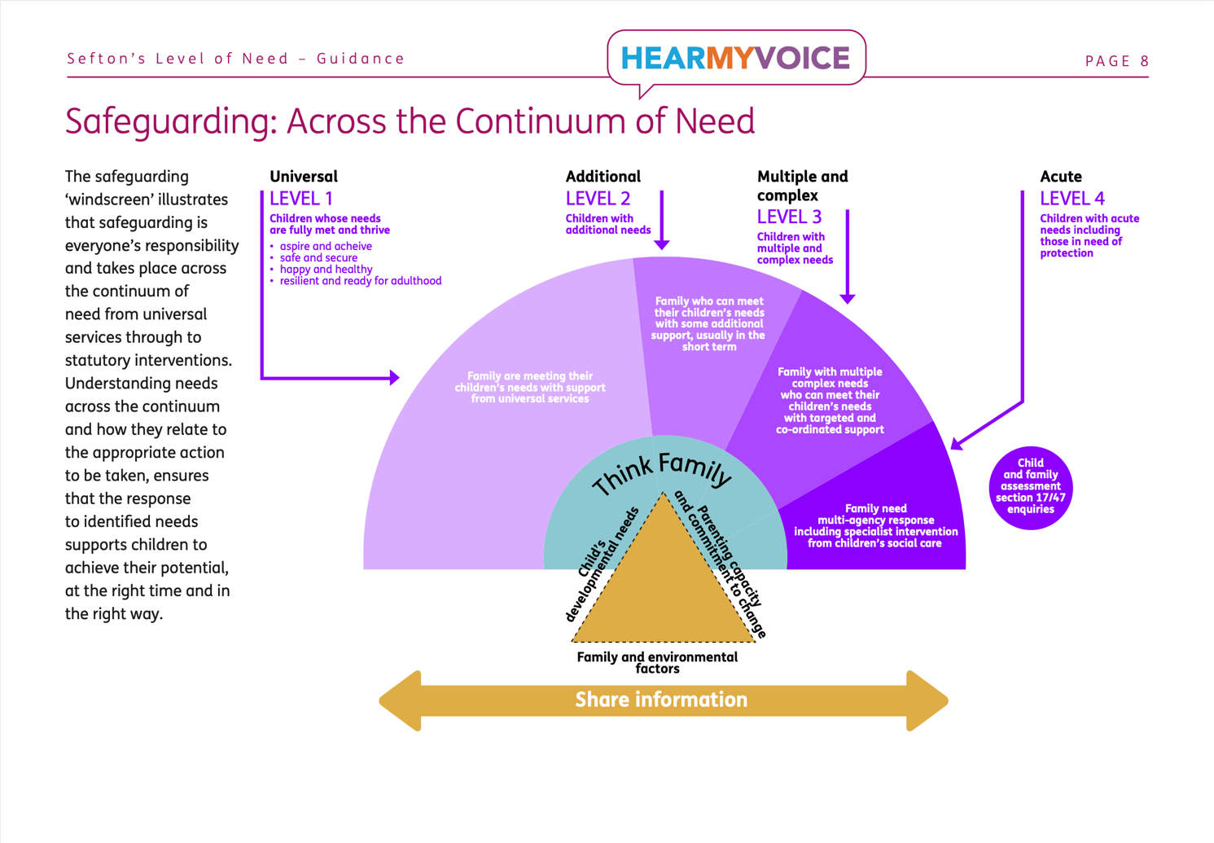
Appendix A
Appendix B
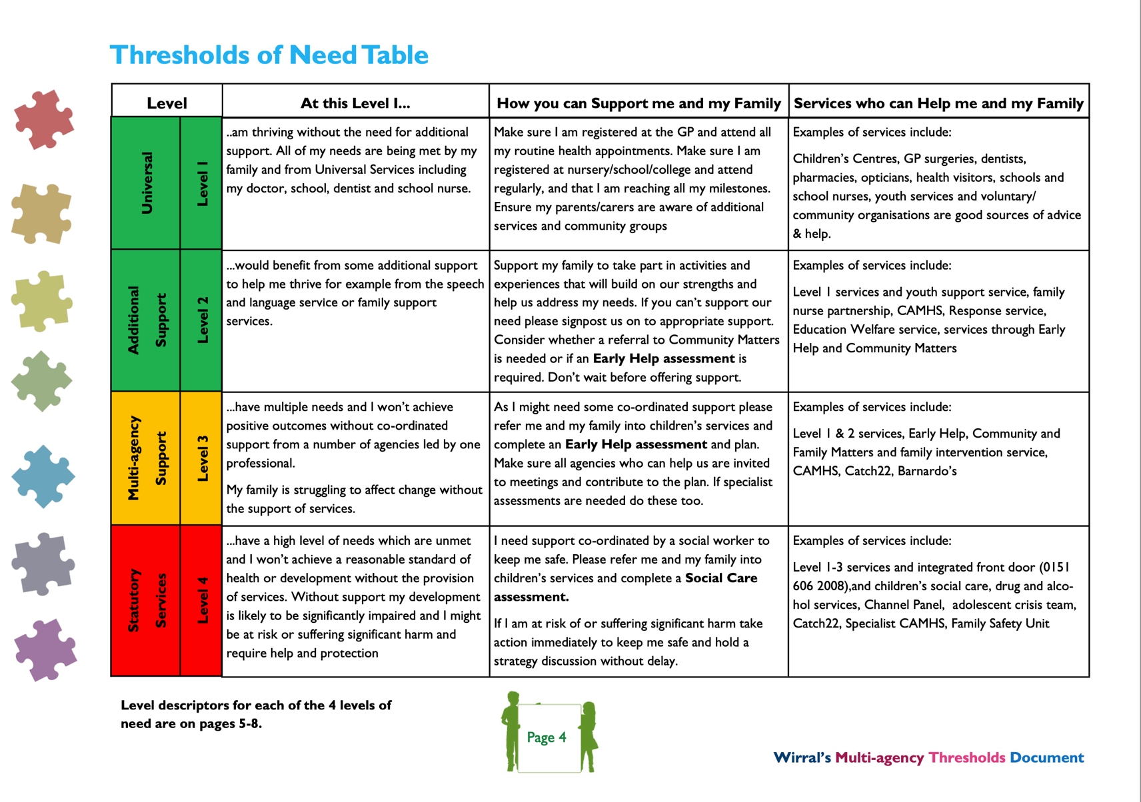

Appendix C
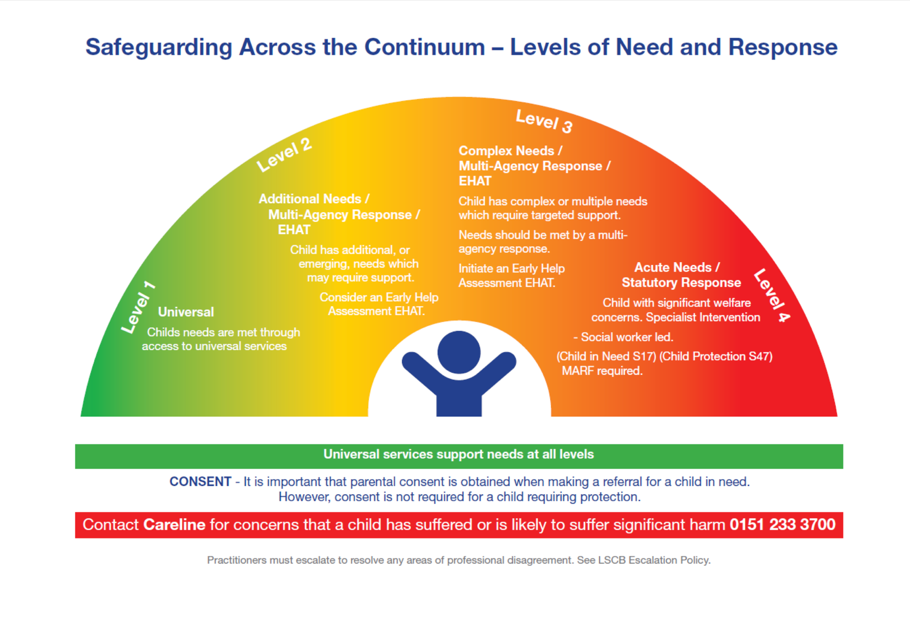
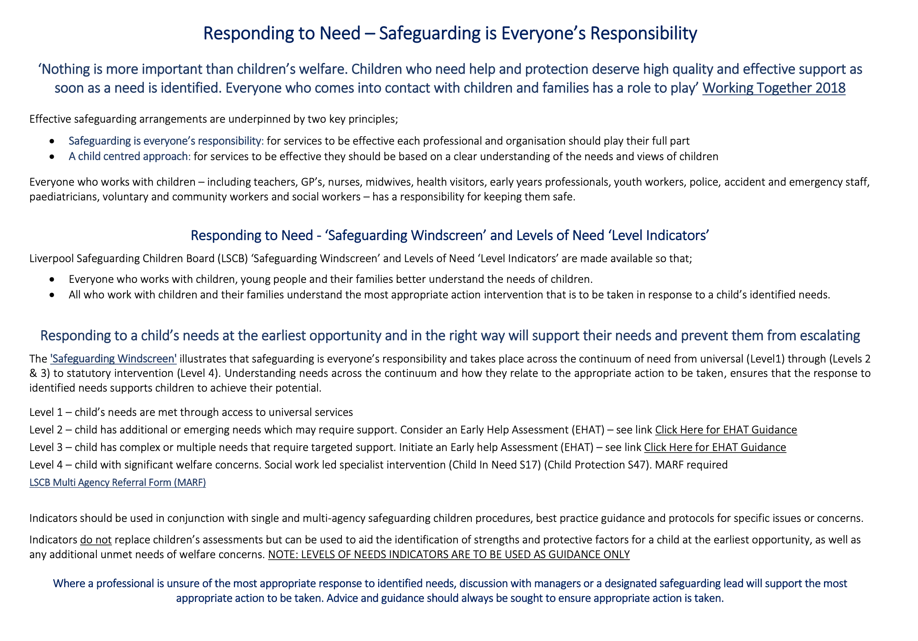
Safeguarding Procedure Flowchart for Children – Appendix D
Concern for child or young person is identified – bring to the attention of the Designated Safeguarding Officer (Lorraine Wood) in her absence the Deputy Safeguarding Office (Sarah Wood).

If it is considered that a child is potentially a child in need (as defined in Section 17 of the Children Act 1989) or if the child is considered at risk of significant harm (as defined in Section 47 of the Children Act 1989) a referral should be made by the worker using the appropriate procedure for the relevant locality. Consent must be sought from caregivers unless there is a clear reason that this would put the child at risk. Details for local social care are:
Wirral - Wirral Integrated Front Door Team: Mon-Fri, 9:00am – 5.00pm Tel: 0151 606 2008
Outside of these hours Tel: 0151 677 6557
Email: IFD@wirral.gov.uk
https://www.wirralsafeguarding.co.uk/concerned-about-a-child/

Sefton - Make a conversational referral by calling the Sefton CHAT team Monday, Tuesday, Thursday 9am-5:30pm, Wednesday 10:30am- 5:30pm (an answerphone service available 9am-10:30am), Friday 9am-4pm Tel 0151 934 4013 Outside of these hours Tel: 0151 934 3555 Children's Help and Advice Team (CHAT) (sefton.gov.uk)

Liverpool – Liverpool Children's Advice and Support Service (CASS): 9:00am-5:00pm Monday-Friday Tel: 0151 459 2606 Out of hours calls will be redirected from the same number. You will then be required to submit a MARF online at: MARF Form - Liverpool City Council

Liverpool City Council: Children's Social Care | Liverpool Family Information & SEND Directory

If the child is at immediate risk, phone 999.

If a decision is made to refer a child to Children’s Social Care Services, the family concerned will be informed of this decision and offered support throughout the process, unless this would place the child at significant risk.

Clearly document the nature of your concerns on the individual’s/family’s file and record the date of the referral. Referral must be recorded in Safeguarding Referral Log in the main office at Bootle/Birkenhead
Contact Children’s Social Care Services if a response has not been received within the same working day.
Clear notes should be kept on file concerning the progress of the referral and discussions that may have taken place with the child, parent, other agencies and Children’s Social Care Services, together with actions taken.

Ensure that the family are kept fully informed of progress at all stages and every effort should be made to minimise distress to the child.

